Dr Patricia Barber
Counselling Psychologist |
Self Esteem Week 4
Biased Expectations

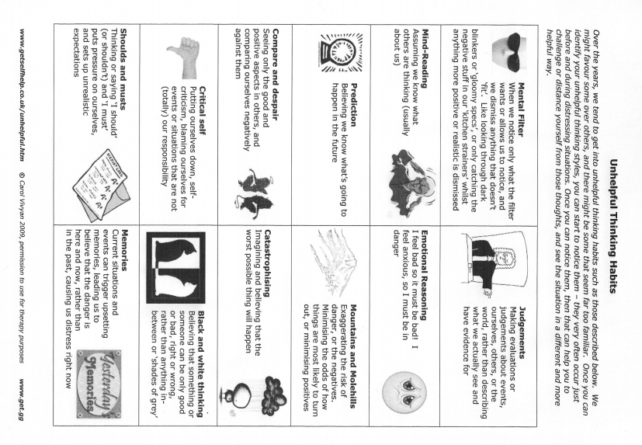

Thought Diary
What is the at risk situation? | How much do you believe it will happen? (0-100%)
What am I expecting? What am I predicting? What do I see happening in this situation? What conclusions am I jumping to? | What emotion am I feeling?  Emotions Intensity (0-100)
Part 1

Part 2
What is the evidence for my expectations? | What is the evidence against my expectations?
How likely is it that what I am expecting will actually happen? (0-100%)

Part 3
What is the worst that can happen? | What is the best that can happen?
What is the most likely thing that will happen? | How does it affect me if I expect the worst?

Part 4
If the worst did happen what could I do to cope?

How else could I view the situation?

Are there any positives in me or the situation I am ignoring?

Part 5
What is a more realistic expectation?

How much do I believe my original biased expectation now? (0-100%)

How intense are my emotions now?

Experimenting with Biased Expectations
Step 1 identify your biased expectations
The situation

My biased expectations

How much do I believe it will happen?

How will I know it has happened?

Step 2 Identify your unhelpful behaviours
____________________________________________________________________________________________________________________________________________________________________________
____________________________________________________________________________________________________________________________________________________________________________
Step 3 Remember your realistic expectations
____________________________________________________________________________________________________________________________________________________________________________
____________________________________________________________________________________________________________________________________________________________________________

Step 4 Identify your helpful behaviours and set up your experiment
____________________________________________________________________________________________________________________________________________________________________________
____________________________________________________________________________________________________________________________________________________________________________

Step 5 Carry out the experiment

Step 6 Evaluate the results
What actually happened?

How much did my biased expectations come true?

Which expectations were supported by the experiment?

What was it like to behave differently?

What did I learn from this experiment?

